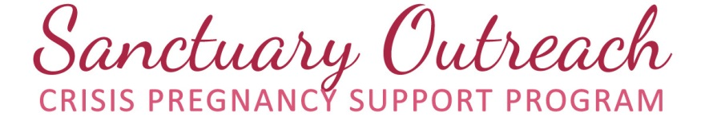
Sanctuary Outreach Statement of Beliefs for Peer Support Volunteers
Please read carefully before signing. If you are uncomfortable with this statement, we can help you find other volunteer opportunities within Sanctuary Outreach or other similar organizations.
Mission: Through active outreach we hope to find women experiencing unexpected pregnancies and connect them with community support and resources. We strive to help faith communities and organizations begin and expand their own crisis pregnancy supports to women in need.
Vision: Together we will build a safety net for pregnant women in need that encompasses Guelph and Wellington County.
Values:
- We believe that every woman and girl, facing an unexpected or crisis pregnancy, should be confident that they are able to carry their baby to term and certain they will have support during and after pregnancy.
- We believe that induced abortion is often detrimental to women’s health, as well as clearly ends the life of their unborn child. For these reasons, it is our belief that it is unethical for us to encourage or refer for induced abortions.
- We believe that an unexpected or crisis pregnancy is a stressful enough situation. Because of this, all support of pregnant women and girls should be rooted in compassion and understanding, regardless of their ultimate decision.
- We believe in the value of both parenting and adoption and support women and girls in choosing and pursuing either option.

I agree with the above mission, vision, and values, as stated, and will do my best to uphold this statement in full as I support women and girls who reach out to Sanctuary Outreach.
________________________________ ______________________________
Signature of Volunteer Date of Signing

